Algorithms and Data Structures – Lab Sheet 02

Question 01)
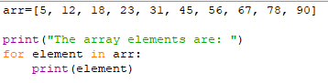

Output –

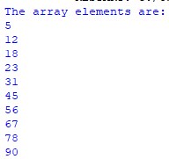

Question 02)
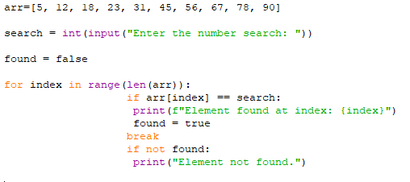

Question 04)

